**DAILY ONLINE ACTIVITIES SUMMARY**

|  |  |  |  |  |  |  |  |  |
| --- | --- | --- | --- | --- | --- | --- | --- | --- |
| **Date:** | **04/06/20** | | | | | **Name:** | **Gulam Rabbani** | |
| **Sem & Sec** | **4th Sem “B” Section** | | | | | **USN:** | **4AL18CS099** | |
| **Online Test Summary** | | | | | | | | |
| **Subject** | | **Microcontroller and Embedded System** | | | | | | |
| **Max. Marks** | | **20** | | **Score** | | | **13** | |
| **Certification Course Summary** | | | | | | | | |
| **Course** | WordPress Training for Beginners From Scratch | | | | | | | |
| **Certificate Provider** | | | **Eduonix** | | **Duration** | | | **4:00:00** |
| **Coding Challenges** | | | | | | | | |
| **Problem Statement: 1 C program and 1 Java program** | | | | | | | | |
| **Status: Executed** | | | | | | | | |
| **Uploaded the report in GitHub** | | | | | **Yes** | | | |
| **If yes Repository name** | | | | | **https://github.com/alvas-education-foundation/gulam_rabbani/tree/master/daily_progress** | | | |
| **Uploaded the report in slack** | | | | | **Yes** | | | |

Online Test Details: (Attach the snapshot and briefly write the report for the same)

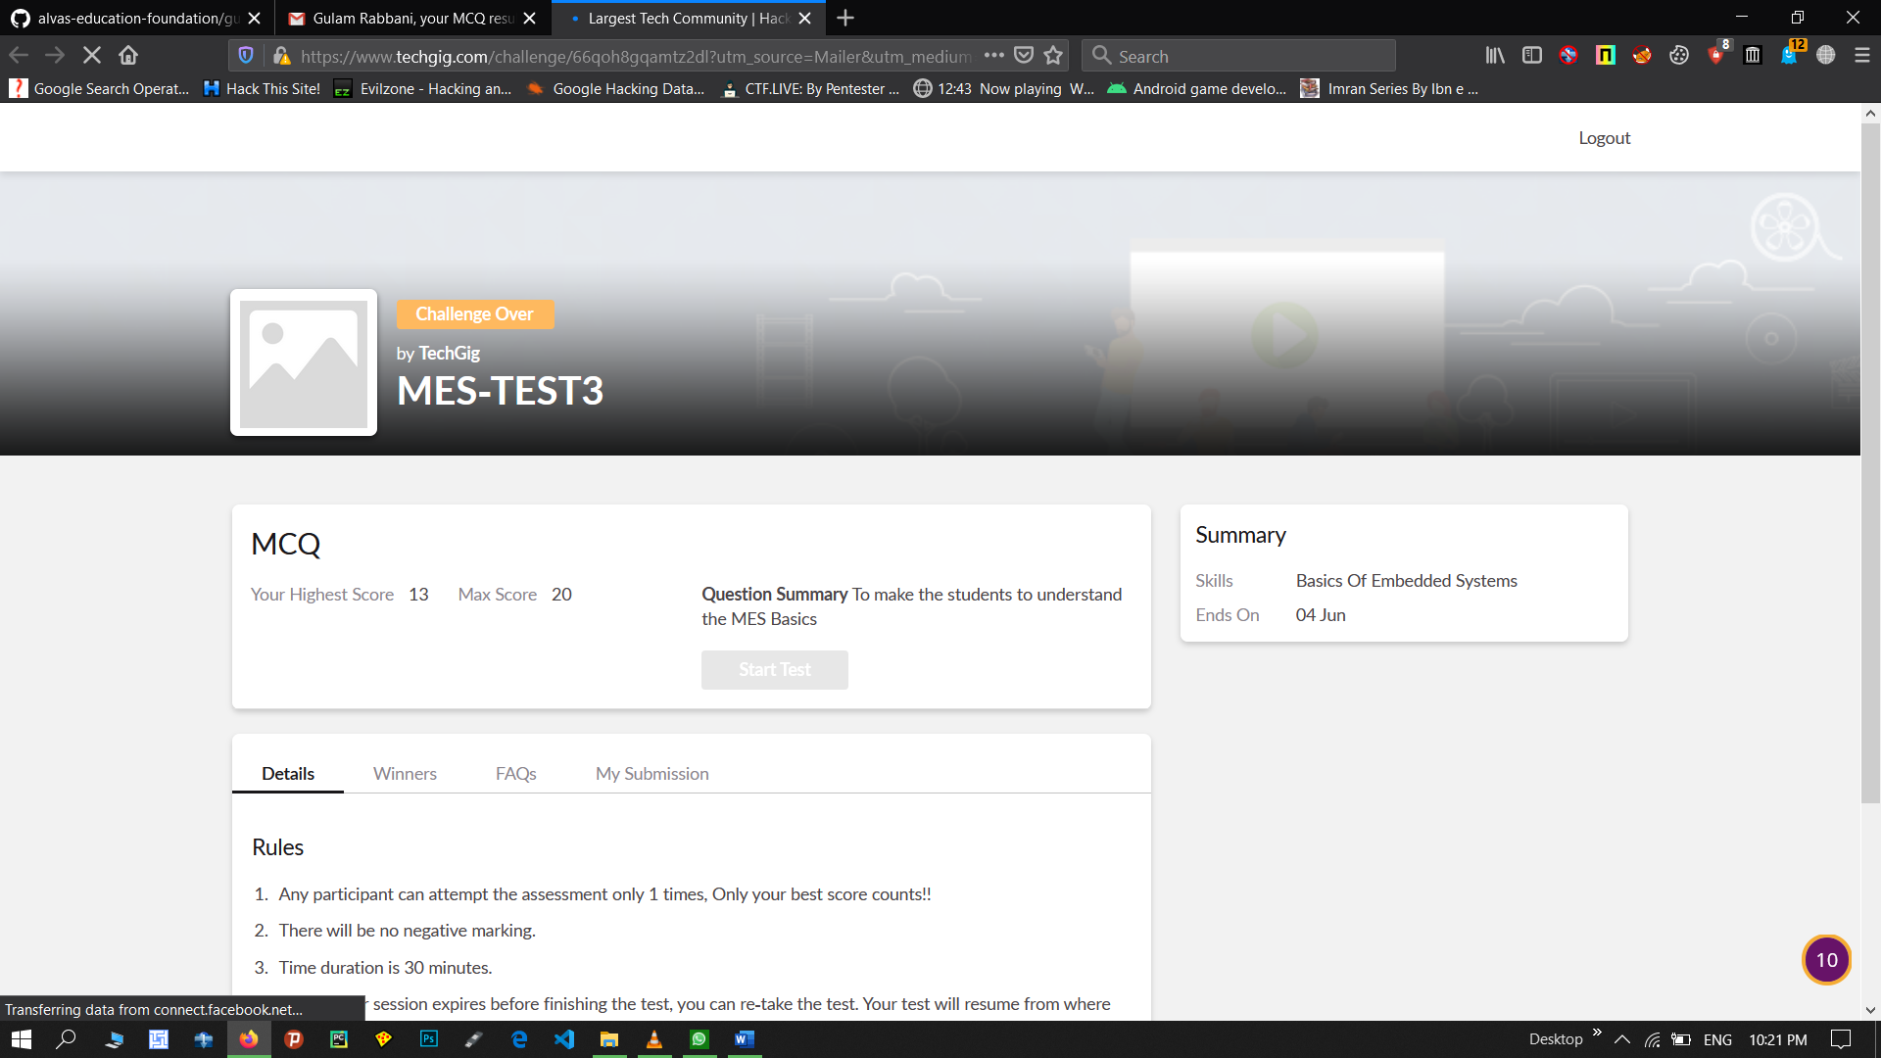

Certification Course Details: (Attach the snapshot and briefly write the report for the same)

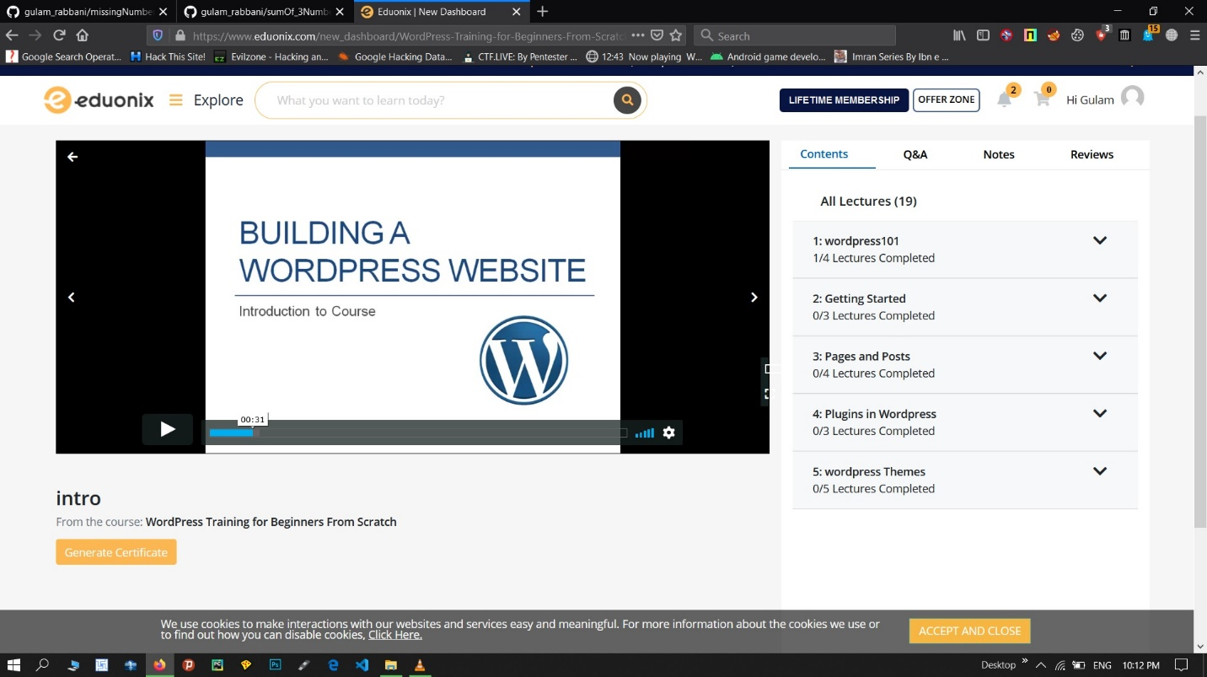

The course title is “WordPress Training for Beginners From Scratch” from the Eduonix, one of the best online course content provider. The course will teach some easy techniques to design a website with world famous CMS WordPress.

Coding Challenges Details: (Attach the snapshot and briefly write the report for the same)

